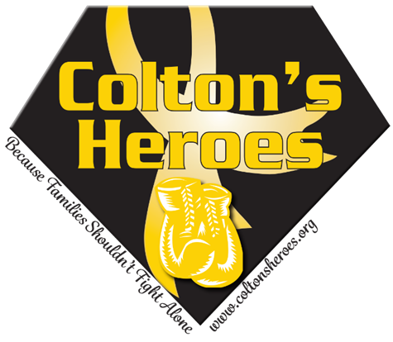

SPONSORSHIP PACKAGES for All Events in 2024
$800 – Gold Sponsor – Banner at ALL Events, Name on Kickball Tournament Shirts, Logo on Website, Logo on Flyer (if paid by 5/24/24) and Table at ALL Events
$500 – Red Sponsor – Yard Sign at All Events, Name on Website
$100 – Orange Sponsor – Name on a Yard Sign at Kickball Tournament

***DEADLINE FOR FLYER is 5/24/24, DEADLINE FOR SHIRTS is 8/9/24,
DEADLINE FOR BANNERS & YARD SIGNS, 9/3/24***

Please email your logo in a high-resolution pdf, jpg or victor file and/or any questions to lhockaday@coltonsheroes.org or janelegraham@coltonsheroes.org

Please mail sponsorship in the envelope that is provided or email us for an invoice to pay by credit card (a 3% service charge will be added for credit card payments)

COLTON’S HEROES PO BOX 6965 PUEBLO WEST, CO 81007

