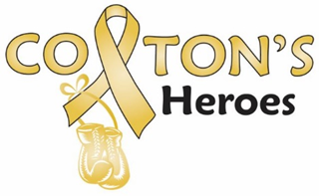

PO BOX 6965n
Pueblo West, CO 81007
janelegraham@coltonsheroes.org
lhockaday@coltonsheroes.org

Dear Potential Sponsors,

We will be having a couple events in 2025, starting with a Poker Run on June 29th and on September 27th our Kickball Tournament, Craft/Vendor Fair and Walk, three great events all in one place, Runyon Field Sports Complex.

In order to make our mission successful, we will be relying on the generosity of businesses and individuals for support.

Colton’s Heroes would like to invite you to be one of our 2025 sponsors. As a sponsor your company will receive thanks and recognition for your association with Colton’s Heroes, a 501(c)(3) non-profit.

With the help from our sponsors, we will provide families with gift cards to restaurants, to local grocery stores and gas stations, help with everyday household expenses or any other needs that may arise from having a child who is dealing with cancer. Also, the past nine years we have sent a child (who’s outlook is not the best) and their family on a fun Christmas Outing, so they can get away from the stresses that they are going through. We have also donated to benefits, fundraisers and funeral expenses. We really need your help to continue to help these families. Please help us, help those who are dealing with the unthinkable, a child with cancer.

Sincerely,

The Colton’s Heroes Board

MISSION
Colton’s Heroes is dedicated to raising awareness of childhood cancer and funds to help families who are dealing with the unthinkable, a child with cancer.

