Barnwell Elementary PTO
Executive Board Meeting
Friday March 19, 2021
Barnwell Elementary via Zoom
March Minutes
Board members in attendance: Sogol Zebarjadi, Lauren Limbaugh, Megan Gann, Michelle Erste, Jen Matheson, Ryan Uptegraph, Erin Kadzis
Mr. Neuhaus
The meeting was called to order at 9:37am.
A motion was made and passed to adopt the agenda.
A motion was made and passed to adopt February’s minutes.
Treasurer’s Report:
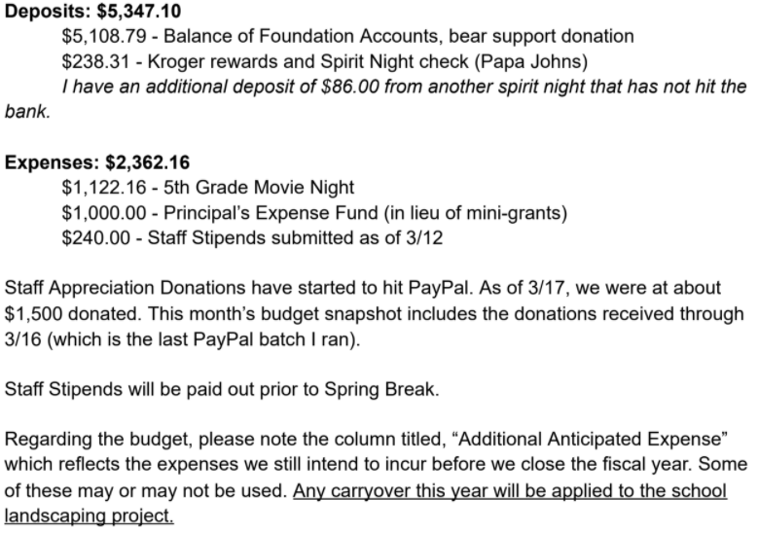
Principal’s Report:
- Many thanks to community (parents, students, teachers) amidst the disconnectedness of the year
- Teachers are thankful for stipends and donuts for 5th grade buddies
- 4th grade classes had to be reshuffled with last 9 weeks and 44 students returning face-to-face. Currently 76% of students are face-to-face.
- Town Hall for GA Milestones; attendance was small; parents can choose whether students take it; survey deadline of parent choice closes soon; plan for Milestones will be developed before Spring Break.
- Briefly discussed teacher appreciation week amidst Covid protocols; flexibility and creativity will still make it a great week
- Left meeting at 10:01am
President’s Report:
- Landscaping update—Blossom Landscaping will install; quote still $23,000; treasurer confirmed this works with budget; will pay 40% up front; install starts week of SB and should finish the following one; we will have to organize volunteers to continue daily watering after installation
  - A motion was made and passed to proceed with landscaping project
- Agenda Cover Contest—student artwork announced 4/23; will consider new sponsor options; cost runs approx. $1,000.
- 5th grade fun day will be on Tues. 5/25; we will use deposit from last year’s Barnival for inflatables and games; it will be a surprise
- Lauren will not serve as president for 2021-2022
VP’s Report:
- Michelle updated on progress for 21-22 slate; confirmed current members returning; discussed options for new recruits.
- Decided to make next board meeting a general one to recruit new volunteers
- Jen updated on teacher appreciation; excited about 2 chairs and potential themes; budget is $1600, and we will also move $620 from ongoing teacher appreciation to it.
- Michelle updated info on School Kits; we are going with a new company that is cheaper and local; on sale mid-May to June; kits will be delivered to school and sort directly to classrooms
- We have 1 final pizza spirit night.
Meeting adjourned 11:00am Minutes submitted by Erin Kadzis

