(#133) Dear Management:

August 28, 2019

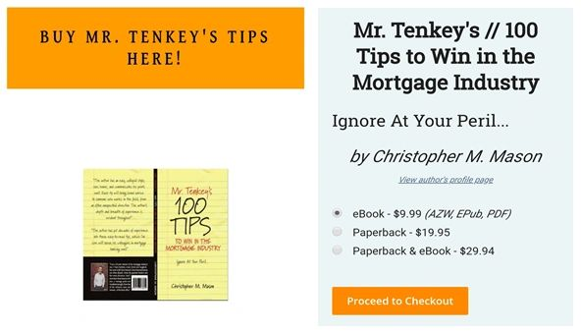

Look Ma!  I'm a PUBLISHED author now!  
  
Anyone else care to see?    
  
Go to [www.mrtenkey.com](http://www.mrtenkey.com/) if you care to have your very own copy too!!!  
  
#mrtenkeytips #chrismasonanalytics