(#136) Dear Management:

September 3, 2019

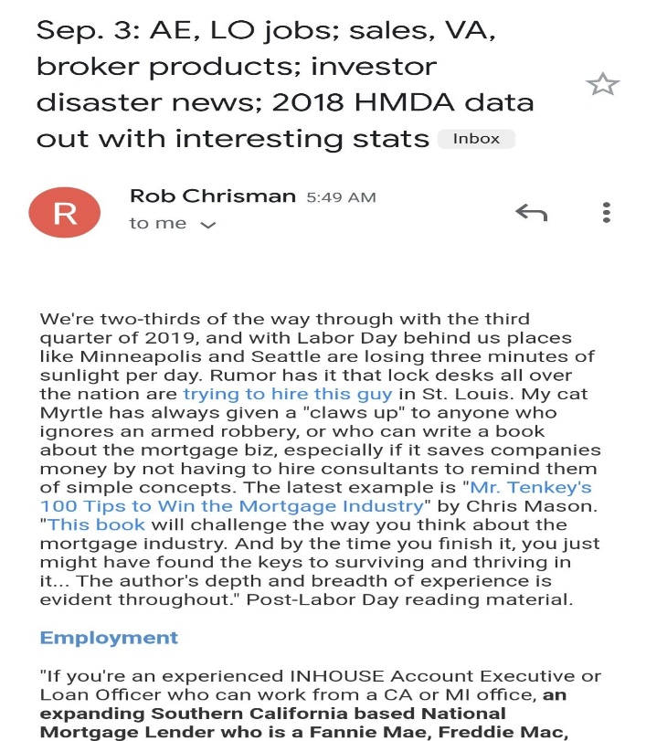

Don't usually post twice in a day, but then this happened...  in Rob Chrisman's daily mortgage industry newsletter...  
  
And in the opening paragraph... I'm gonna faint...  
  
Sep. 3:  [www.robchrisman.com](http://www.robchrisman.com/)  
  
We're two-thirds of the way through with the third quarter of 2019, and with Labor Day behind us places like Minneapolis and Seattle are losing three minutes of sunlight per day. Rumor has it that lock desks all over the nation are trying to hire this guy in St. Louis. My cat Myrtle has always given a "claws up" to anyone who ignores an armed robbery, or who can write a book about the mortgage biz, especially if it saves companies money by not having to hire consultants to remind them of simple concepts. The latest example is "Mr. Tenkey's 100 Tips to Win the Mortgage Industry" by Chris Mason. "This book will challenge the way you think about the mortgage industry. And by the time you finish it, you just might have found the keys to surviving and thriving in it... The author's depth and breadth of experience is evident throughout." Post-Labor Day reading material.  
  
Fainting now...  
  
Find my book and blog at [www.mrtenkey.com](http://www.mrtenkey.com/)  
#mrtenkeytips #chrismasonanalytics