(#155) Dear Management:
September 30, 2019
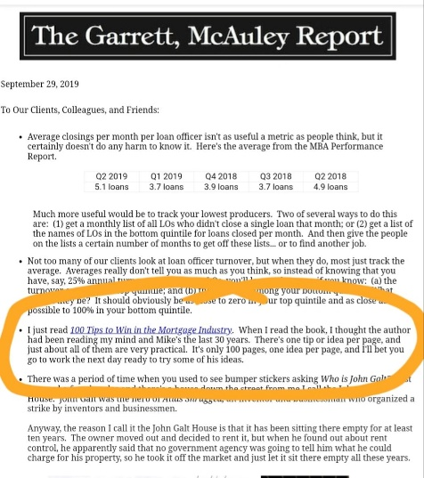

One of my mentors in the mortgage industry JUST mentioned my book, in his weekly newsletter (attached). YEAH!!!
So the theme of the day is: Mentors...
We all need them... Joe Garrett is one of mine, and hopefully yours has been just as sharing with their wisdom...
But remember... just like Uncle Ben told Peter Parker (aka Spiderman), "With great wisdom, comes great responsibility"...
So also... don't forget the "responsibility" to pay it forward.
It's the best way I know, to honor their efforts.
So... now GO! Pay it forward peeps!
Find my book and blog at www.mrtenkey.com
#mrtenkeytips #chrismasonanalytics

