(#160) Dear Management:
October 7, 2019
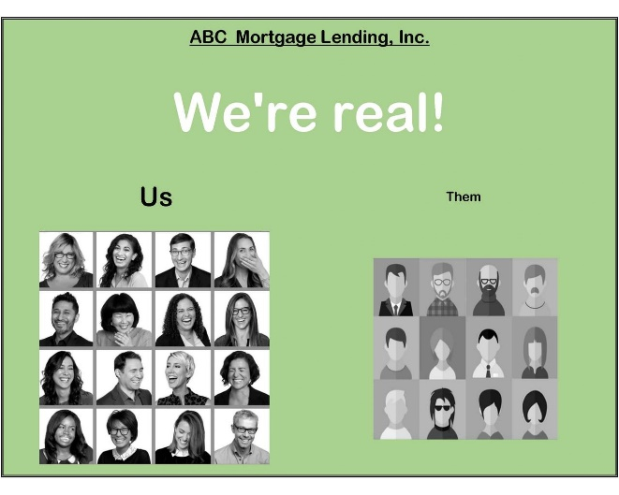
Something different this week! Something I'm calling... "An accountant in his CREATIVE habitat".
And YES, accountants CAN be creative... a graphic designer (meh), but creative... well you be the judge.
I'm devoting my posts to kicking around thoughts of... "Why should they pick us, to do their loan?"
Just like Baloo sang in the Jungle Book, "You've got to accentuate the positive... Eliminate the negative..."
So find your best feature and flaunt the hell out of it...
Now... onto Day 1's idea... hope you enjoy...
Find my book and blog at www.mrtenkey.com
#mrtenkeytips #chrismasonanalytics

