(#163) Dear Management:
October 10, 2019

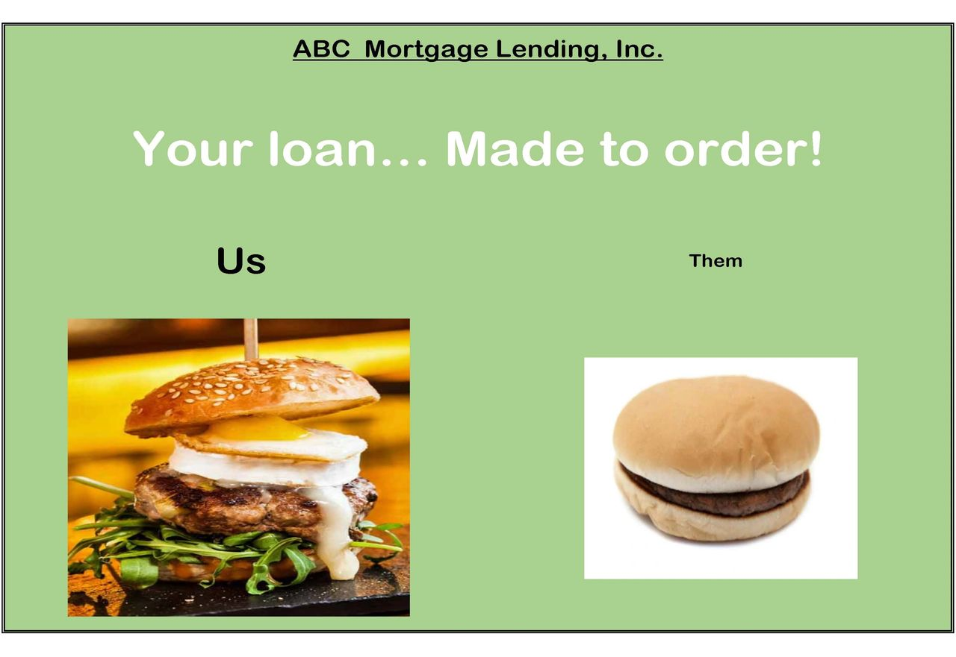
(Theme week) - Day 4 - "An accountant in his CREATIVE habitat".
The industry has become pretty vanilla with its product offerings. We did that to ourselves... think back to 2007-08, if you're still asking why...
So in a world where we're all selling the same hamburger.
What do you do to differentiate?
I say... throw an egg and some arugula on it and call it a masterpiece.
So now go, find your version of Burgerville's special sauce... that keeps them coming back for YOUR cheeseburger.
Burgerville = my happy place
Hope you enjoy...
Find my book and blog at www.mrtenkey.com
#mrtenkeytips #chrismasonanalytics

