(#185) Dear Management:

November 18, 2019

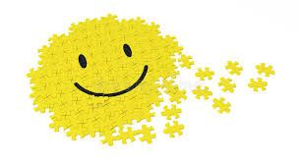

You know that great feeling you get when you grab that one puzzle piece, match it to the right location, press... and it just locks right into place?  
  
Isn't it GREAT?  One piece down, and now you're off to find the next...  
  
Well, that's the feeling you should feel... every time you make a decision.  
  
You're looking around at the many options provided to you by your staff... you grab hold of one, lock it in place and move on to the next one.  
  
If you don't... how are you ever gonna glue that project together, hang it on the wall and call it art?  
  
Just sayin...  
  
Find my book and blog at [www.mrtenkey.com](http://www.mrtenkey.com/)  
#mrtenkeytips #chrismasonanalytics