(#190) Dear Management:

November 25, 2019

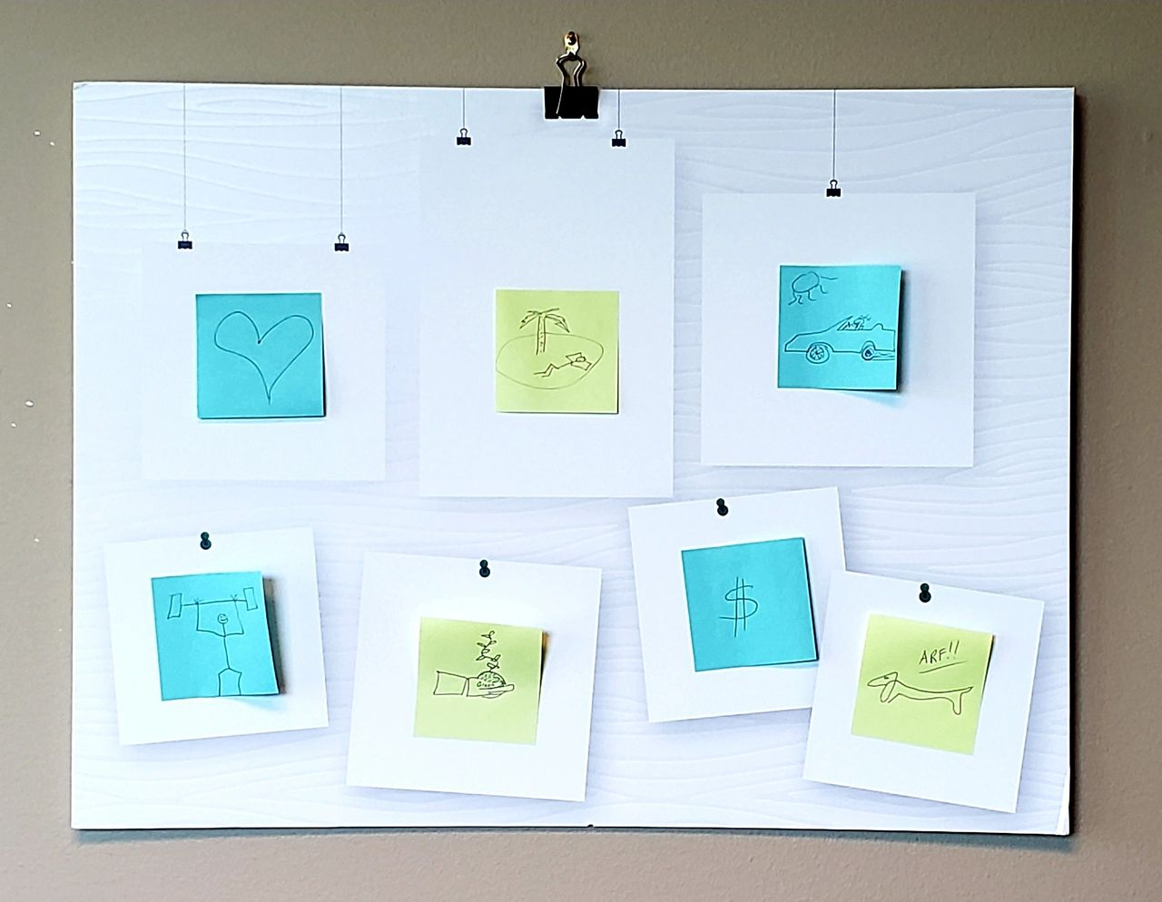

I believe that Vision Boards cast your vision in the WRONG direction.  
  
Goals are great!  But putting pictures of dreams on a board... takes your eye off the road to those dreams.    
  
For example, athletes that visualized gold medals and standing on the podium... often slacked off on training and performed worse then their competitors that focused on the actual tasks needed to reach that medal podium.  
  
So attached is my vision board.  I put as much effort into it, as I felt I would get from it.  
  
Instead I set my focus on an internal road map of how to get from point NOW to point DREAMS.  
  
Starting at top left:  
  
1) I have love in my life and work hard to keep it.  
2) I'm working toward obtaining the financial nest egg to retire and see as many palm trees as I can.  
3) I've gotten my convertible and drive it as much as I can.  
4) I run two times a week to stay big and strong.  
5) I create and play in the yard as much as I can.    
6) I wrote a book, continue my blog, etc. to raise my $ quotient.  
7) And nothing better than Dexter the wiener dog!  
  
So, in my best Ronald Reagan impression...  
  
"Mr. Management, tear down that vision board...  
Mr. Management, road map your vision instead!"  
  
Find my book and blog at [www.mrtenkey.com](http://www.mrtenkey.com/)  
#mrtenkeytips #chrismasonanalytics