(#196) Dear Management:

December 5, 2019

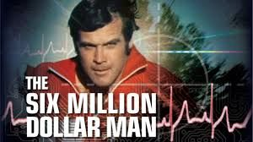

What does CRM stand for?  
  
Let me help, CRM = Customer Relationship Management  
  
And even though the software and gadgets to help in this process, have gotten (as it did with the six-million dollar man - bigger... stronger... faster...).  
  
The core goal remains the same... turn customer data into loans.  
  
THAT should never be lost.  
  
And neither should the fact that there were great and top producing loan officers (back in the day)... that ONLY used a blackberry and ACT! (as their software of choice).  
  
So as you follow that yellow brick road to OZ, to see the wizard... and ask what is the best-est, great-est, most wonderful-est new CRM out there?  
  
Remember who will be using these tools... your loan officers.  
  
So you may be thinking - "We can rebuild them. We have the technology. We can make them better than they were. Better...stronger...faster."    
  
But your loan officers may be thinking - "Wow that's neat, but I'll stick with my excel spreadsheet, outlook groups and my cell phone.  It does the trick."  
  
MORAL - Remember who you're buying these fancy gadgets for and make sure these are tools THEY will use and that ARE USEFUL to them.  Otherwise, it will be a COSTLY mistake.  
  
Find my book and blog at [www.mrtenkey.com](http://www.mrtenkey.com/)  
#mrtenkeytips #chrismasonanalytics