(#200) Dear Management:

December 11, 2019

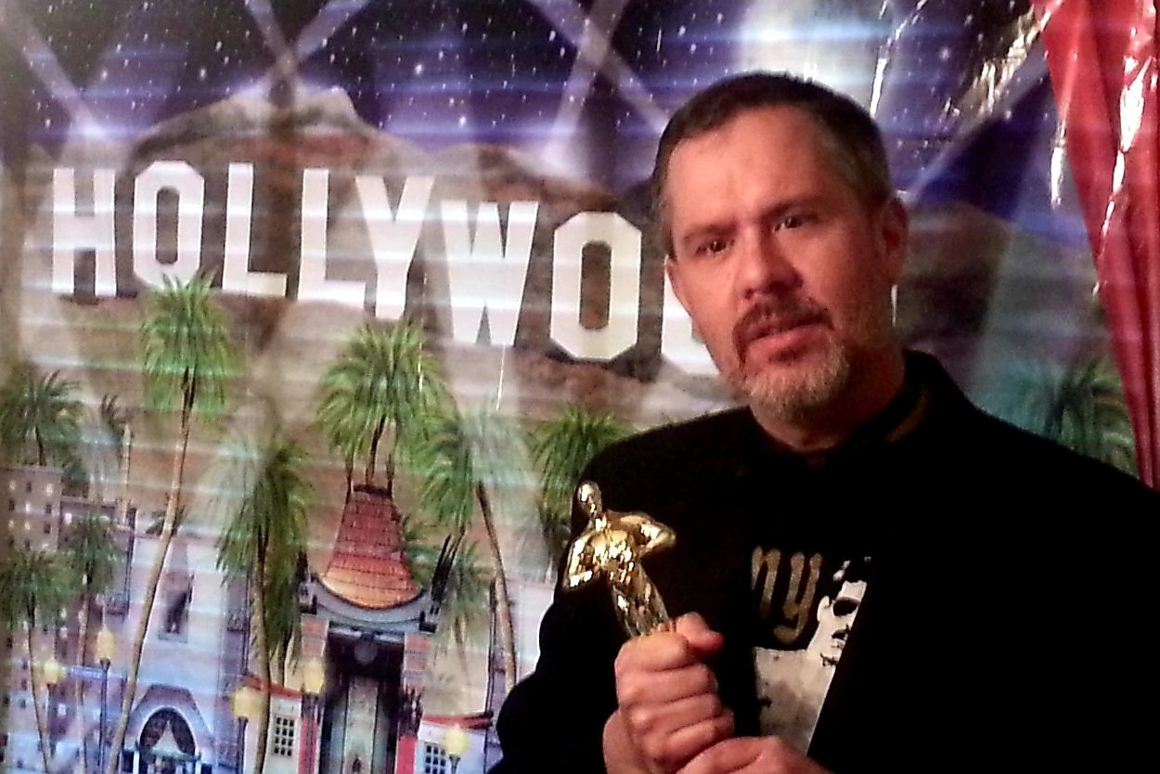

This is my 200th post!  If this was a TV series, I'd be well into in my 10th season... syndication for years baby!  
  
But this is just my little ol' blog...  so no Emmy for me...    
  
I still have hopes though... that some big-time Hollywood producer catches a glimpse and devises some sexy plot twist of international intrigue, about a NonQM loan gone bad...  
  
I smell an Oscar people!  
  
But alas I'm still having fun... giving a voice to the deepest darkest reaches of the back office.  
  
And speaking of voices...  
  
I was asked something the other day... and my response was...  
  
"Why yes, I do... I do, of course do speaking engagements!"  
  
But I'm not your father and these aren't your father's type of speaking events.  
  
If interested in more details, contact me through my website below.  
  
Cause if you liked my book, you'll like me SOOOOO much more in person.     ;)

Sidenote - Don't you just love the empathy in my eyes... for the little people...?  
  
Find my book and blog at [www.mrtenkey.com](http://www.mrtenkey.com/)  
#mrtenkeytips #chrismasonanalytics