(#203) Dear Management:

December 16, 2019

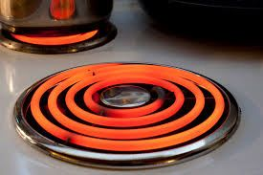

So... which adviser would you choose?  
  
Here's the scenario:  
  
You are in a fancy kitchen, you see this vintage stove... it's one of those old style electric ones.  One of the elements is glowing a beautiful red.  It entices you. You must touch it...  But as your hand moves closer, you get the following advice.  
  
(Basic adviser) - "That's a great idea, Sir! Let me try too..."  
  
(Average adviser) - Tries to stop you with, "That's gonna hurt!"... but then stands to the side with petroleum jelly and plastic wrap to fix you back up after you get burned.  
  
(Super-Duper adviser) - "I have tried this path before and it burns severely. If you really want to touch the surface, let's get you an induction stove. It glows bright also, and you can touch away to your heart's content."]  
  
So again... which adviser would you choose?  
  
Hint - DON'T be basic... and who wants to be average...  
  
Find my book and blog at [www.mrtenkey.com](http://www.mrtenkey.com/)  
#mrtenkeytips #chrismasonanalytics