(#204) Dear Management:

December 17, 2019

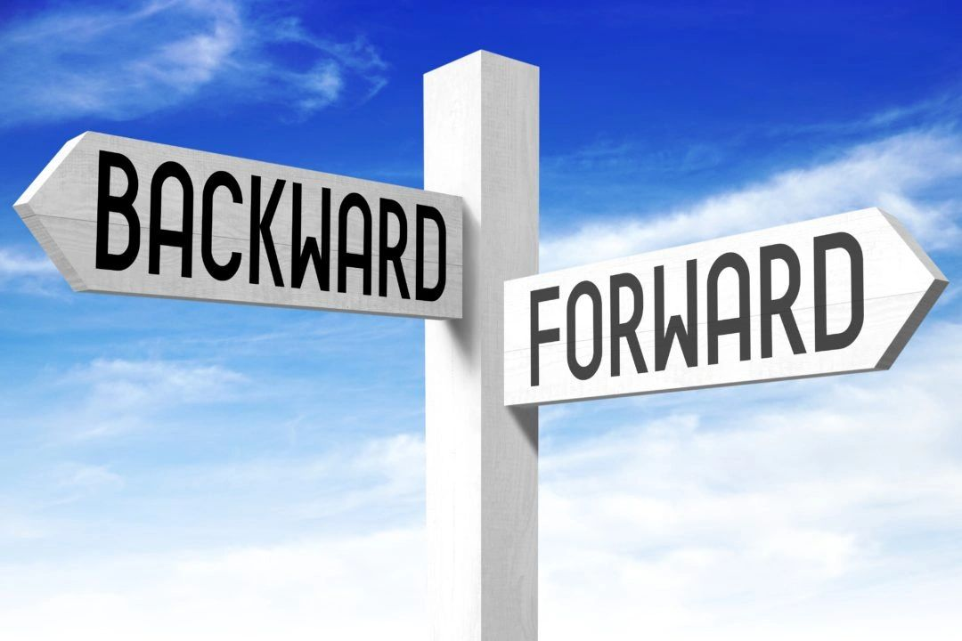

I'm gonna compare your company now... to 6 months, even a year ago.

What would I see?

Significant change or significant similarity???

And with that change, has it moved you forward?

TRUTHFULLY evaluate this people... the true answer says more than you know.

About the people working for you, as well as the people who lead them (hint - you).

Always forward people!

Find my book and blog at [www.mrtenkey.com](http://www.mrtenkey.com/)

**#mrtenkeytips #chrismasonanalytics**