(#206) Dear Management:

December 19, 2019

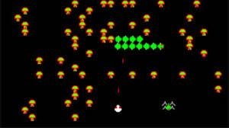

Did you hear about the new birth at the zoo?  
  
A first ever five-headed centipede was born.  
  
It's a complete miracle of nature... but, it was born with one slight issue it'll have to overcome.  
  
Each head seems to only control 1/5 of its legs... so it's been noticed that when the heads are not in sync, neither are the legs.  
  
The poor thing just turns itself into a pretzel.  
  
But do you know what's worse?  
  
When your company's leadership does the same thing to your own company!  
  
SO, just play centipede... DON'T be an out-of-sync multi-headed one!  
  
Find my book and blog at [www.mrtenkey.com](http://www.mrtenkey.com/)  
#mrtenkeytips #chrismasonanalytics