(Mr. Tenkey's Tips #220) www.mrtenkey.com

January 10, 2020

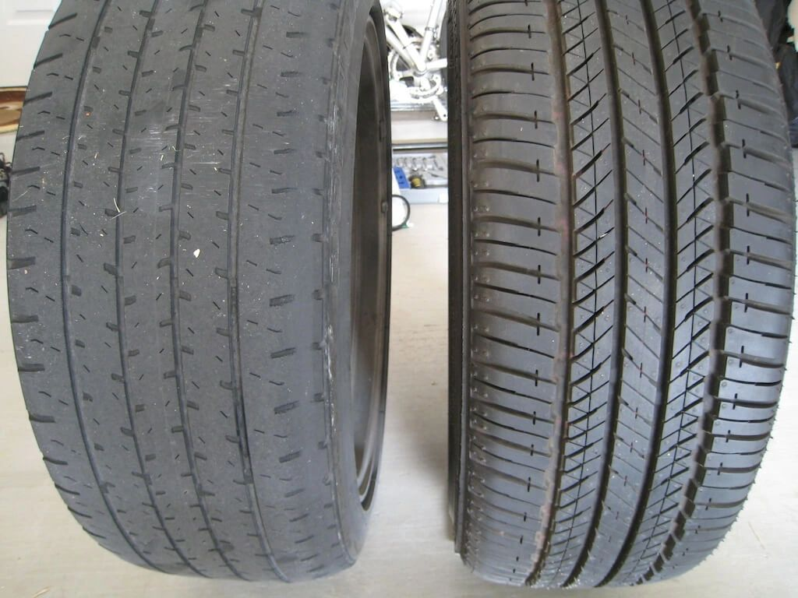

Dear Management:  When bringing on newbie loan officers... it's important to remember that they are NOT indentured servants.  There is no debt to be paid for you training them.  
  
You decided to bring them on... you saw something in them... you placed the bet... hoping it would pay off in more production, and eventually income to your bottom line.  
  
So instead, how about thinking of them as you do... tires on your car???  
  
You buy tires, knowing at some point... they all will wear out.    
  
And sometimes they don't hold up, only lasting 10,000 miles.  You learn from that purchase, move to replace them and hopefully this time it's a brand that lasts.  
  
But sometimes, it just clicks and the ride is comfortable and you double the mileage that was expected for the tire.  Yeah you! and yeah them!  
  
Hell, maybe you even re-tread a pair and get even more mileage out of them.  
  
Moral - YOUR job is to buy the best quality tires you can, at the best price, that give you the best, most long-lasting ride.  
  
So stop worrying about the potholes in the road, and focus on the journey...  
  
Happy travels.