(Mr. Tenkey's Tips #221) www.mrtenkey.com

January 13, 2020

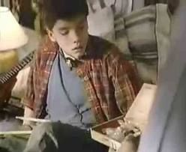

Dear Management:  Remember that old commercial that taught us... oops we just may... be teaching bad habits to our kids?

Here, let me remind you.  "I learned it from watching you, Dad!  I learned it from watching you!"

Cause THEY DO learn from watching... as do YOUR direct reports.

Always look into a mirror as to how you:

Interact with your team... cope with stress or adversity... and share in accomplishments.

And if you forget where that mirror is???

It can be found in THEIR actions, interactions, stumbles and accomplishments.

So be best all you want...  but be a BETTER example!