(Mr. Tenkey's Tips #226) www.mrtenkey.com

January 20, 2020

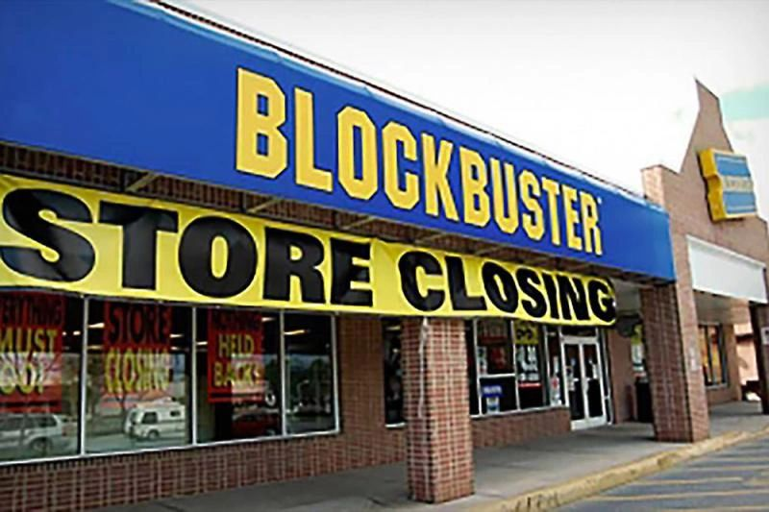

Dear Management:  Learn something from franchise growth (and failure) of the past...  
  
Because if growth and longevity isn't planned out well...  it can be a costly endeavor.  
  
Remember Blockbuster video?    
  
They decided selling VHS was the thing to KEEP doing...  and their thoughts on streaming video?  "Nah, that's just a fad"...  
  
Big mistake, right?  
  
So what about you?  What are you selling?  And not only the product itself, but HOW are you distributing it?   Is it the best option?  
  
For example:  
  
Maybe, just maybe... taking an app by hand, is the mortgage equivalent to VHS of the past.  
  
Just sayin...