(Mr. Tenkey's Tips #227) www.mrtenkey.com

January 21, 2020

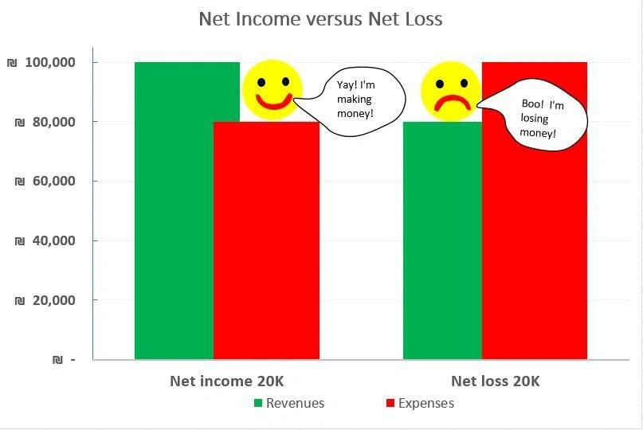

Dear Management:  Another lesson from (Post #226) growth strategies... after you have nailed down the product and distribution structures...  
  
Is to answer the next question... of how to, or IF to open that new profit center???  
  
So, do some research of the market... the margins to be had, the product mix to be sold, the commission levels supported, the avg rent costs, the availability of staff, etc.  
  
And then, and ONLY then... armed with that data... fashion together a sales team AND cost structure that is supported by the product mix, in which your company can win.  
  
THAT is the only way to make sure the number at the bottom of the income statement makes you smile...  and not frown.  
  
Always smile peeps!