(Mr. Tenkey's Tips #228) www.mrtenkey.com

January 22, 2020

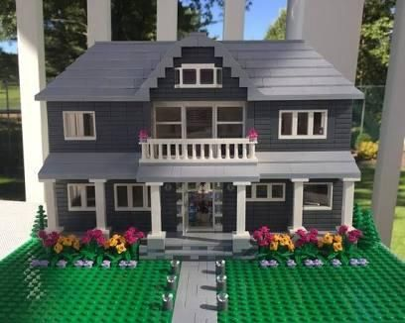

Dear Management:  Let's say, I'm the GREATEST HOME BUILDER OF ALL TIMES!!!  
  
I've won numerous awards for my stellar worksmanship and cost-saving construction methods, etc.  
  
I even just completed building the (pic attached) home.  So yes, very impressive!  
  
BUT, I digress...  
  
Because no matter how good a builder I may be, the end product and process will be LESS...  
  
IF the architect completes the blueprints... THEN continues to add changes to:  move walls or take down walls... add dormers, or even adds another floor for that matter... you get my point.  
  
Out the window... goes a chance for forethought or efficiency...  
  
Blueprints matter peeps!    
  
So plan properly first!  Then set, with no regrets!