(Mr. Tenkey's Tips #229) www.mrtenkey.com

January 23, 2020

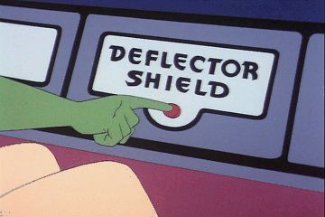

Dear Management:  So, if I (Mr. Tenkey) was a superhero... my arch nemesis would be Mr. Deflector.  
  
Who is that? you ask...    
  
Well... (and yes there are female deflectors too, but Mx. just didn't flow)...  
  
But I digress, Mr. Deflector is a person who can sidestep the pointing fingers of accountability faster than a speeding bullet.  
    
How can this be? you ask...  
  
Well, by throwing every special gamma bio-deflection technique they have, to bend those fingers elsewhere... by:  
  
1) Implementing the tried and true, squirrel maneuver  
2) The dreaded laser light pointer tactic  
3) The trail-less data dumping, to information requests  
4) The, "Is that Elvis?" technique  
5) And the all-powerful flattery button  
  
What can be done? you ask...  
  
Well, as we all know, accountability is an all-powerful currency to obtaining truth, justice and the American way... for all business entities.  
  
So I fight a good fight!  
  
Armed with the one true "kryptonite" to this scourge of the business underbelly...  
  
FACTS!  
  
And now you know...