(Mr. Tenkey's Tips #230) www.mrtenkey.com

January 24, 2020

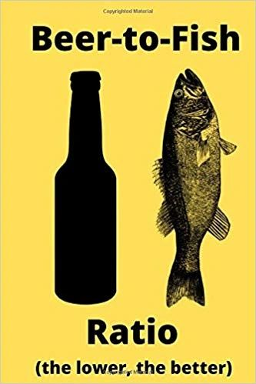

Dear Management: Ratios matter people... even the funny ones that document the relationship between beer and fishing.  
  
And even if, only being created for a punch line... I do have a small issue with the setup.  
  
For me, it's the whole chicken or egg concept... of which came first.  
  
Do you create the desired metrics to produce results, to THEN be evaluated?  
  
OR  
  
Do you decide on your desired results and THEN create metrics to prove those results?  
  
One leaves objectivity, reality in the setup... one potentially skews the results.  
  
So go... fish...  
  
And DON'T predetermine that "lower is better", as the pic attached states.  
  
Instead... at the end of the day, tell me how many beers were drank? And how many fish were caught?  
  
We'll THEN calculate ratios... and see if:  
  
More beer means more fish?  
Less beer means less enjoyment?  
More beer means more expensive fish you'll have to buy on the way home from the river?  
Etc.  
  
Moral - Let the results give you data to analyze outcomes... instead of letting a pre-desired outcome determine which ratios to use.  
  
Now you know...