(Mr. Tenkey's Tips #232) www.mrtenkey.com

January 28, 2020

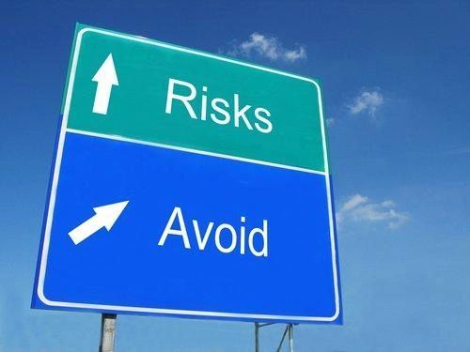

Dear Management:  EPOs (a 2nd day)... because it's not just about mitigating them after they happen, but why not just AVOID them instead?  
  
A couple ways to do this...  
  
1st)  Know what triggers them.  An EPO is triggered by a loan that is paid off within a pre-determined amount of time, as stated in your investor's reps and warrants.  
  
This can range in time, but the normal "safe" zone is after 6 mths.  So that's anytime beyond 6 mths... from purchase date NOT the date you funded the loan.    
  
2nd) Trust and educate your loan officers to work for you and not against.  Let them know what is at stake.  
  
Teach them techniques of listening to the transaction for signs.  
  
Like... someone needing a loan pronto, but who has a second home that is on the market.   Red flag people!  What will they do with that extra money?  Have you asked?  
  
And one last mention... an EPO is not only when a loan is fully paid off.  Substantial payment of 70 to 90% of the balance, can also be a triggering event.  
  
So be diligent, trust and educate... a winning combination in my book.  Literally!