(Mr. Tenkey's Tips #235) www.mrtenkey.com

January 31, 2020

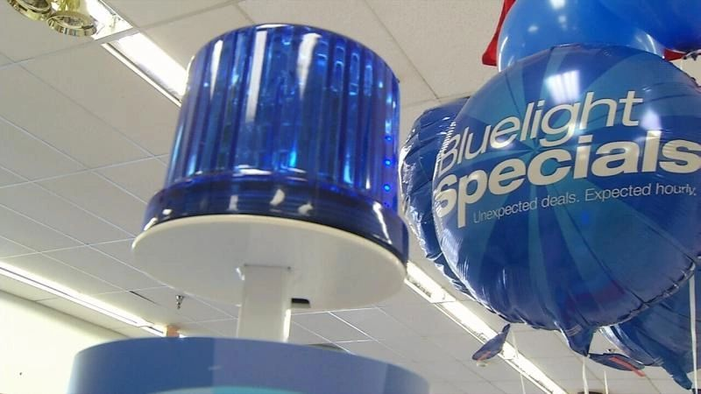

Dear Management:  What kind of pricing concessions are you giving up on average?  
  
First - Do you know this answer?  Cause you should...  
  
Second - What is the amount?  0 to 20 bps?  21 to 75 bps?  76 bps or over?  
  
If it's 76 bps or over, I wouldn't worry about pricing concessions, I'd rather... worry about your over-all pricing strategy instead.  
  
Because all I see is you pricing yourself too high to start, and having to rely on a blue light special to save your butt.  
  
Plus you might be putting yourself into the bad end of the fair lending zone... depending on to whom and how you're implementing such large concessions.  
  
And calm down now... I'm not saying concessions aren't gonna happen.   But mitigating them and understanding WHY they are happening... and IF they are needed, is key!  
  
Keep them to the lower end of the scale...  
  
BUT also, not so low that you're not able to test the ceiling... on the rates of your various markets.  
  
Make sure to use pricing concessions as a tool...  NOT a crutch.