(Mr. Tenkey's Tips #237) www.mrtenkey.com

February 4, 2020

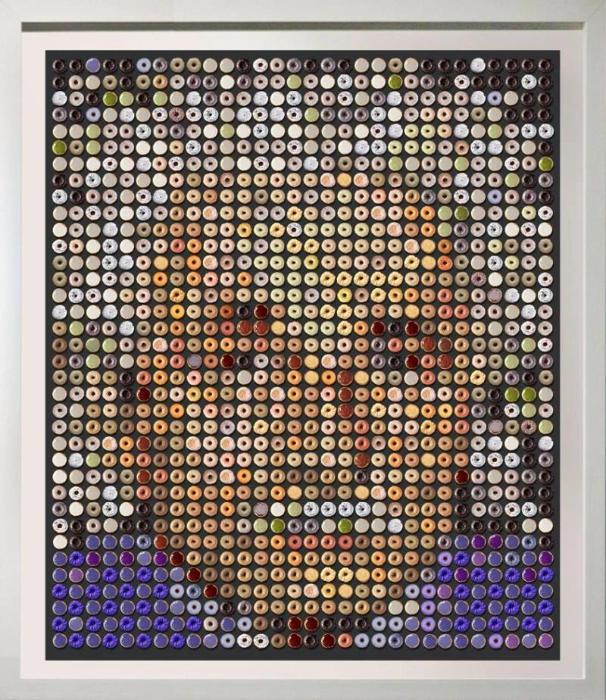

Dear Management:  You don't have to be Einstein (made of donuts - backup if you donut see it)...  
  
To know the difference between marketing and branding.  
  
Marketing is devising tactics... to get people to 1) actually taste your donuts and 2) to continue to buy more donuts.  
  
Branding is building a bond between your donuts and your customer's inner sense of joy, and desire for reliability.  
  
One is a date... the other is a marriage.  
  
Spend your time and money  
appropriately,  
deliberately  
and wisely...  
along these two paths...  
  
Now you know.