(Mr. Tenkey's Tips #240) www.mrtenkey.com

February 7, 2020

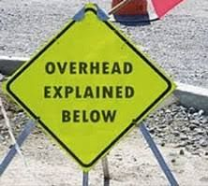

Dear Management: Conversations often go sideways when discussing company overhead allocations and fairness...  
  
And most of the sideways-ness (yes it's a word) comes from regional, area and branch managers... that don't see a relationship between those allocations and their bottom lines.  
  
So then you point out all the things the company does for them directly... and all, that is actually in those allocations.  
  
They come back with, "OK but not ALL that other stuff... not directly..."  
  
And then... things go sideways, picking apart every little expense item.  
  
BUT I have a new comeback for them... and it goes like this...  
  
I have no kids... yet i pay taxes for others to sit in front of a teacher, and learn how to be an educated addition to the population.  
  
So in a very loose relationship to me, I live in a better society because my allocation of taxes... goes to better the life of kids I don't even know.  
  
Some overhead allocations are like that. Not every expense in that bucket will directly relate to you... but in-directly the value and strength of the company as a whole... does and can, when needed.  
  
I'll then finish up with something like, "so there!"