(Mr. Tenkey's Tips #246) www.mrtenkey.com

February 17, 2020

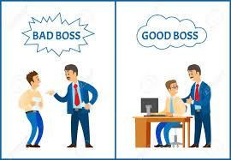

Dear Management:  The way in which you react to conflict often says more about your leadership ability, than many other actions you might make.  
  
Let's say, some employees have pushed back on a decision you have made.  
  
You could... go into full defense mode, back arched, pull the supervisor card and demand submission...  
  
OR  
  
You could evaluate why your co-workers/employees are pushing back?  Listen to the cause of their push-back.  Work through things... to a win-win solution kinda thing.  
  
You could even thank them for their caring... for the health of your company/department/etc.  
  
YOUR CALL  
  
But one path gets you... simply an obedient do-er, the other gets you a complex diligent think-er.  
  
Now you know.