(Mr. Tenkey's Tips #254) www.mrtenkey.com

February 27, 2020

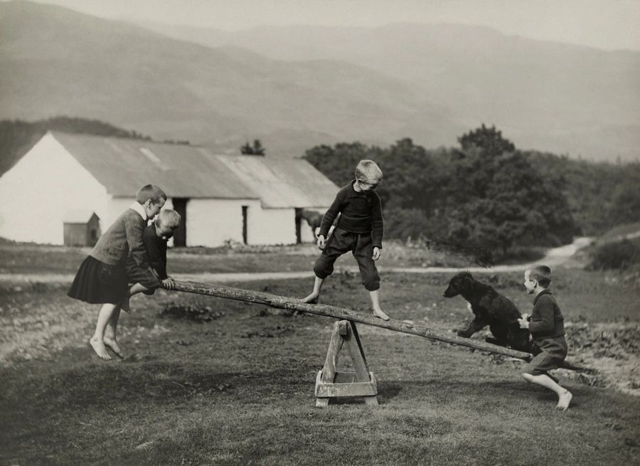

Dear Management:  Continuing the conversation on growth...  
  
The idea of growth, MUST move beyond the perception of "build it and they will come".  
  
You can have what you think is the best online platform money can buy and/or create... BUT without a great marketing strategy... NO ONE will know.  
  
You can have what you think is the best operations team out there... BUT without a reputable person to promote this fact... NO ONE will know.  
  
You can have what you think is the best leadership team alive... BUT without a succinct direction/vision... NO ONE will know.  
  
You can have what you think is the best (whatever)... BUT without a succinct, solid sales voice... marketing and promoting what is "best" about you... NO ONE will know.  
  
Operations and sales are the two sides of your company's teeter totter.  
  
Be out of balance...  
  
and NO ONE will come.