(Mr. Tenkey's Tips #257) www.mrtenkey.com

March 3, 2020

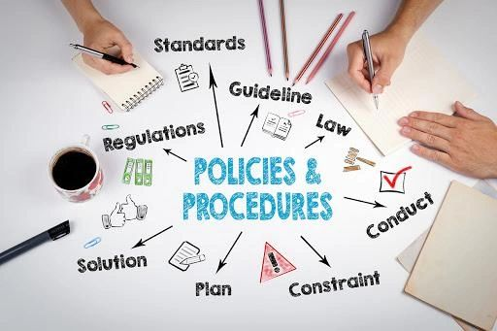

Dear Management:  A policy not followed...  
  
Is a policy that you DON'T have.  
  
You can say this or that about what your company does...  
  
But if you sidestep a policy (or procedure), even just once...  
  
Then you open the door to side swiping all credibility that your employees (let alone the outside world) have of your word... as an organization.  
  
And this IS different from just changing a policy.  Because policies are fluid and do evolve based on a multitude of factors... so they do require adjustments over time.  
  
But CONSISTENCY in the execution is paramount, of said policy and/or a change to it (effective dates of the changes, reasoning through the needs for those changes, etc.).  
  
Policies (and procedures) are your rules of engagement in everything... from decisions, to execution, to results analysis.  
  
Writing a policy for a company is like giving your word to your employees and the outside world, that you will conduct said items according to these rules and guidelines.  
  
Destroy that... and you destroy accountability, reliability, efficiency and all the other "eees" that I didn't list.  
  
So... make your company keep its word peeps!