(Mr. Tenkey's Tips #259) www.mrtenkey.com

March 5, 2020

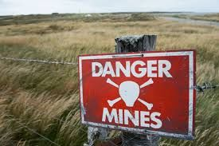

Dear Management:  As a leader, have you created a minefield... for leaders under you in the chain of command?  
  
Let's see...  
  
- Have you trained them to effectively predict how you would land on a question (if you were asked independently)?  
  
If no, land mines have been laid...  
  
- Have you forced questions to go through these new leaders and the chain of command, instead of bypassing and answering the questions brought directly to you instead?  
  
If no, land mines have been laid...  
  
- Have you worked discreetly with said person to adjust an undesirable decision they may have made, rather than contradicting them publicly?  
  
If no, land mines have been laid...  
  
Hopefully you can see the minefield that is created by these actions...  
  
Also, other employees will see these new leaders not as "deciders" themselves but rather "relayers" of your decisions... and hence just bypass them and go to you instead.  
  
It's not good peeps!  It's stiffling to growth and productivity.