(Mr. Tenkey's Tips #260) www.mrtenkey.com

March 6, 2020

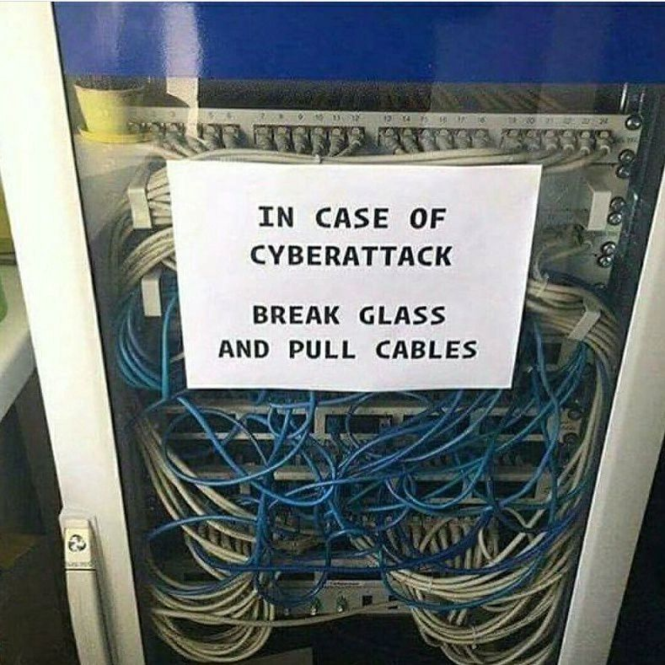

Dear Management:  Think you need cyber insurance?

Me too (IN THEORY), but in reality... it often turns out to cost LOTS and cover LITTLE.

If any of you have had a better experience, get at me...

With the onslaught of data breaches and cyber attacks, you'd have to have your head in the sand if you weren't looking at ways to mitigate these risks and costs.

But the problem is, EVERYONE is having claims... and insurance coverage only works when there is a balance, of risk and reward.

And many don't think so, but insurance companies have to make money too.

So their reaction is to look for any excuse possible to avoid paying out the full amount of a claim.

Hence, I and many others are findings these cyber plans practically worthless.

What to do?

My post, my views...

But if I'm off, prove me wrong... please.