(Mr. Tenkey's Tips #262) www.mrtenkey.com

March 10, 2020

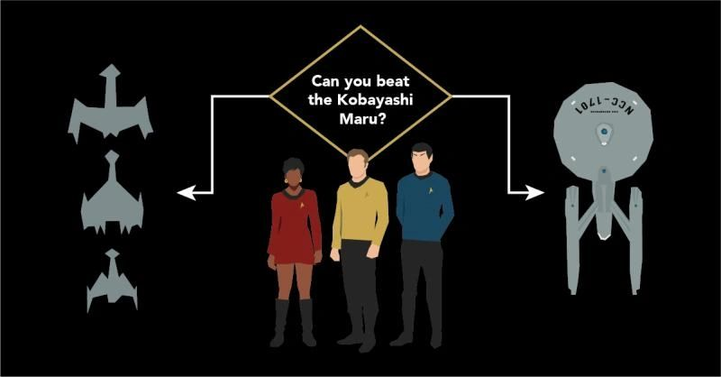

Dear Management:  On a fictional tv show, the kobayashi maru lives on for eternity... as a wonderful show of cunning and chutzspa.  
  
In real life... it's a terrible training method for employees, at any level.  
  
The method, fails employees on the way in... and out of the training simulation.  
  
Fail 1 - gives no or little instruction on the percieved way(s) to correctly complete a task or what the desired outcome(s) may be.  
  
Fail 2 - scolding the employees when they do not perform to a level, that was desired but never shared with them.  
  
Outcome - frustrated employees who could have completed the task effectively...  but feel cheated by the process.  
  
AND like Captain Kirk did, your employees may find a "win", in a no-win situation.  
  
They either...  
  
Push back and shed light on Fail #1, all while risking the "Wrath of Khan" and their job.    
  
Or they just cheat the test, and quit.  
  
So, as I see it... the ultimate out comes are 3-fold.  
  
The employee wins in their own way and just quits.  
  
The employee gets thru to the trainers... and they both win, with the newly enacted procedural improvements.  
  
Or  
  
The employee fails, the scoldings continue... and the repetitive training simulations roll on.  
  
Ugh... train wisely people.