(Mr. Tenkey's Tips #265) www.mrtenkey.com

March 13, 2020

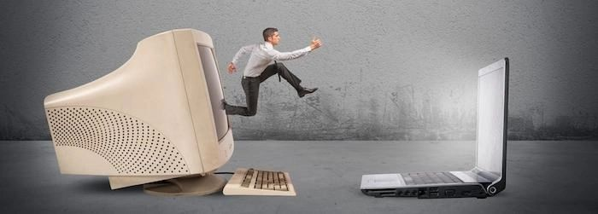

Dear Management:  With all the money that you've spent on technology...  
  
Have you funded more loans?  more quickly?  Has your cost-per-loan gone down?  
  
Based on industry reporting, the answer generally is a big "NOPE".  
  
And one reason keeps coming to the surface... it's that they aren't EMBRACING IT!  
  
Meaning, along with the purchase... you have to implement new ways of getting from point A to point B.  Too many companies are forcing their old processes and methodologies on the new technology INSTEAD of allowing the new technology to dictate changes from the old ways.  
  
For example... let's go back to when scanning first started.  People didn't fully embrace a true paperless file.   They would still print out parts, appraisals, etc... and carry it around the office to processing, underwriting, etc.  And then... at the end, they would scan the file and store another copy in the file cabinet graveyard... as backup.  
  
You can see the inefficiency right?  NO ONE does this anymore.  
  
People embraced technology, changed their processes, added a couple more monitors... and then all those companies had fire sales on the huge banks of file cabinets they no longer needed.  
  
Now go!  Be ahead of that curve!    
  
Embrace peeps!  Embrace!