(Mr. Tenkey's Tips #267) www.mrtenkey.com

March 17, 2020

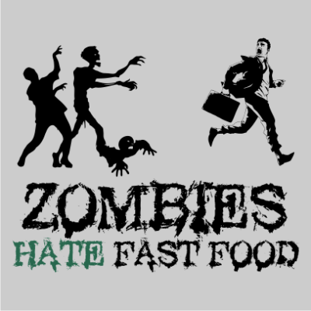

Dear Management:  All this virus talk on the news... has got me dreaming about zombies.  
  
And what I remember of those dreams is... at ALL times, but especially during our current "crisis" times...  
  
Indecision is WORSE... than choosing ANY other action (good or bad)!  
  
Because just imagine... 100 zombies are coming straight for you!  
  
What are you going to do???    
  
1)  Indecision - You stand in place... and they come EAT you.  
  
2)  Bad decision - Run toward them!  (And again, still better than indecision.)  BECAUSE... as you move toward them you can re-evaluate the decision you just made... and turn and run the OTHER way.  
  
or  
  
3)  Good decision - Run AWAY from the zombies!  
  
  
So, choose wisely peeps!