(Mr. Tenkey's Tips #271) www.mrtenkey.com

March 23, 2020

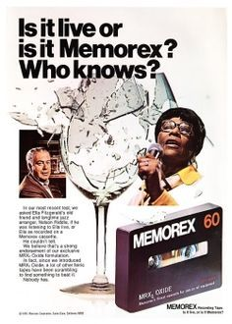

Dear Management:  "Is it Live or is it Memorex?"  
  
An old reference, but a relevant concept today... in regards to borrower contact.  
  
Because, you have to keep them engaged and informed.  
  
What better way to pack a punch... then a PERSONALIZED video email???  Let them know the what ups, the how they beez, the I'm here for youz....  
  
And make sure it sounds genuine.  Make sure it sounds like you're telling them the information LIVE.  
  
Not like you did ONE recording for all your borrowers and just dubbed in their name...  
  
Not good peeps!  
  
And yes efficiency is great, but a single generic video WILL NOT DO.  The information has to be tailored to your borrower's needs.  
  
Also, you need not create a manifesto, so no longer than 90 secs, preferably closer to a minute.  
  
Now go... comb that hair, clean up the background of that camera angle and make sure the dog is out of barking range...  
  
Annnnnnd ACTION!