(Mr. Tenkey's Tips #273) www.mrtenkey.com

March 25, 2020

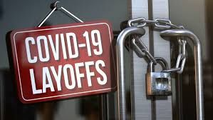

Dear Management:  You just locked a loan... it's calc'd into your hedge position...and guess what?  
  
Your borrower just got laid off, due to covid-19.  Who knows how long?  Who knows if the business survive?  
  
Whatcha ya gonna do about that?  Hopefully you have your fall-out rate set with a good buffer...  
  
That same loan has already funded...  it's sitting on your warehouse line... then you get the same news.  
  
Now whatcha gonna do?  Hopefully you have enough capital to self-fund that loan...  
  
That same loan has already been purchased by a secondary investor... then the news comes in.  
  
Still have a plan of whatcha gonna do?  Hopefully you don't mind EPDs and repurchasing that loan back...  
  
Now multiply that by all the borrowers dealing with the current crushing financial peril...  
  
And BROKERED shops... you aren't immune to all this...  the effects may be different, but there are a lot more similarities than not.  
  
SOOOOOOOO...  Have you worked through the above scenarios?  
  
WHATCHA gonna do?    
  
These are answers that you should be answering...