(Mr. Tenkey's Tips #274) www.mrtenkey.com

March 26, 2020

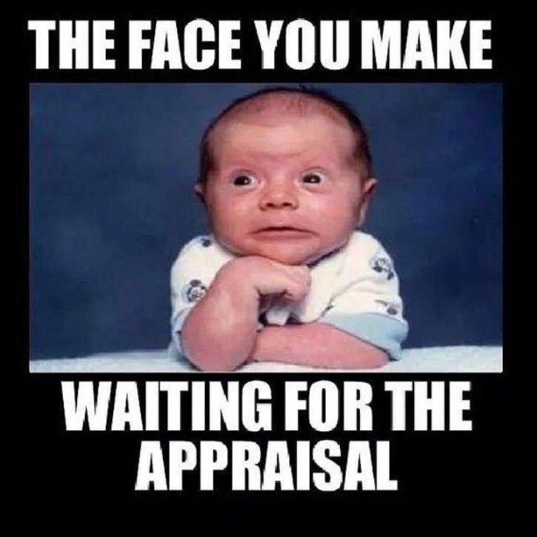

Dear Management:  Did you ever think the day would come, when the reason an appraisal failed was NOT because of bad comps, property conditon, etc...  
  
BUT RATHER... because the appraiser wasn't allowed into the house due to the coronavirus?  
  
WELL, that day has come!  
  
Whether it's because there is a sick person in the house, or the occupants suspect the appraiser might bring it into the home...  
  
Either way, that loan that you've spent time pushing through your production line...  
  
Is now a CANCELED loan???  
  
So, instead... be ready for this.  
  
Be thinking alternative levels of appraisals... be thinking appraisal waivers... be thinking anything that gets that loan funded.  
  
It's a creative time peeps!  Keep thinking!