(Mr. Tenkey's Tips #275) www.mrtenkey.com

March 27, 2020

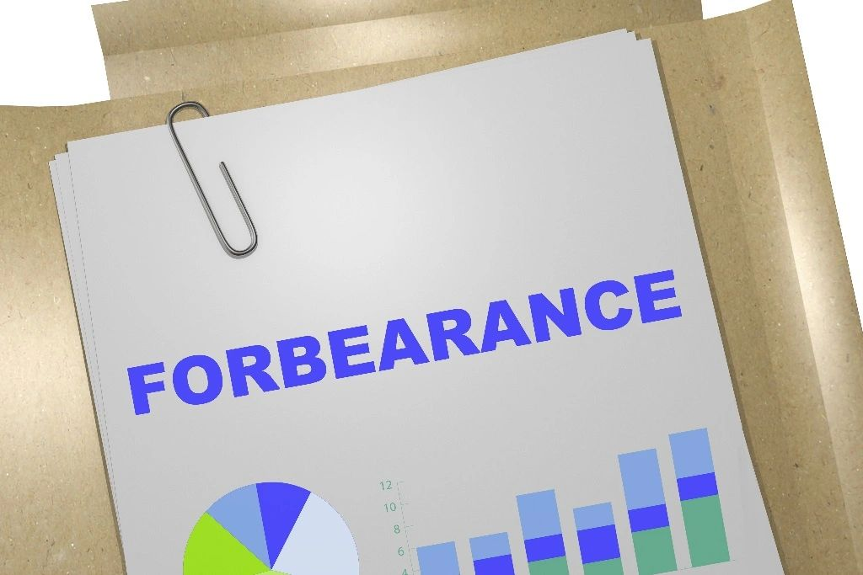

Dear Management:  I heard a spot on NPR, detailing that homeowners who have lost income or their job due to covid-19, are eligible for relief... that relief being reduced or suspended mortgage payments for up to 12 mths.  
  
So right now, federal regulators are ordering lenders to offer homeowners "FLEXIBILITY" on all loans backed by Fannie or Freddie... and they're suspecting the rest of the industry will follow.  
  
NOW... that's A LOT to take in for the industry.  
  
Because along with ALL THAT... has come LITTLE TO NO guidance.  
  
So here's my questions, just off the cuff:  
  
How far down the line of "lost income" or "lost job", does one qualify as "being" impacted by covid-19?  
  
What is the definition of this "flexibility" being offered to borrowers.  
  
What does a forbearance program even look like?  
  
Who qualifies for reduced versus suspended payments?  
   
What terms are acceptable to place into this program?  
  
How does the lender get made whole? Do they?  
  
What are the acceptable fees to charge to be made whole? Is that even allowed...  
  
That's a lot of UNKNOWNS...  
  
Ugh, this reminds me of 2007 all over again... but now we're all wearing blindfolds!