(Mr. Tenkey's Tips #276) www.mrtenkey.com

March 30, 2020

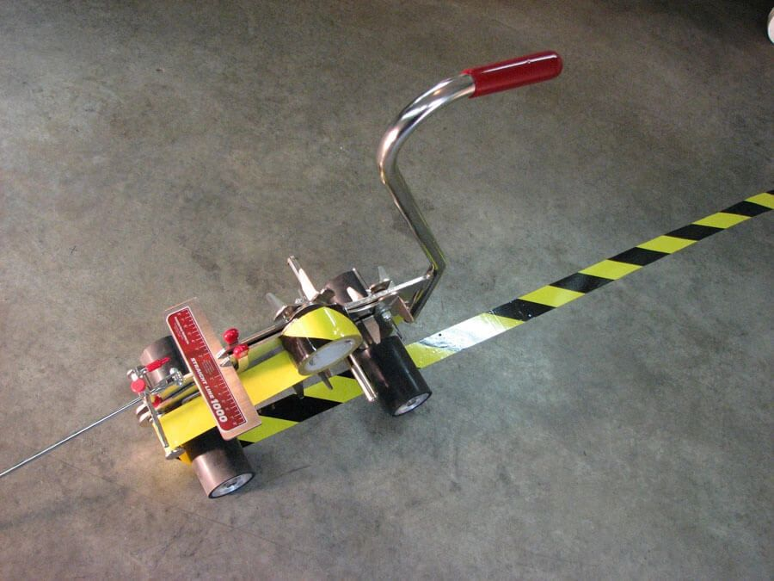

Dear Management:  These aren't the only warehouse line caution signs that you need to be paying attention to...  
  
Have your warehouse lines been sending you lots of emails recently???  
  
Because even though covid-19 is wreaking havoc... fundings ARE continuing.  
  
And with rates this low, volume projections (hopefully continuing beyond this crap) are getting as scary as virus counts.  
  
The warehouse lenders are seeing these projections too. SO the emails keep coming...  
  
1) No more funding of Non-QMs.  
2) No more funding of Construction loans.  
3) A LOT more scrutiny on JUMBO loans.  
4) What's next?  
  
But you can't blame them.  They're just creating a business model that increases capacity, as those projections... estimate their needs.  
  
And so... what are you doing?  
  
Do you just stop funding those types of loans? Find a WH line to add, that DOES fund those loans? Fund them yourself?  Something else?  
  
There are numerous strategies... but you have GET TO working through each of them.  
  
So WORK IT people!