(Mr. Tenkey's Tips #278) www.mrtenkey.com

April 1, 2020

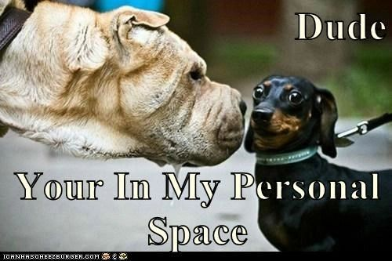

Dear Management: Prediction #2... of GOOD changes in our industry, that will come from this BAD virus.  
  
The concept of personal space will mean a completely different thing... when EVERYONE is working from home.    
  
And, while it won't be everyone... what we're going through right now, is forcing acceptance...  
  
Acceptance, that more employees will be working from home... from now on.  
  
The questions of WHO and IF IT would work out long term???  
  
Is being BETA tested as we speak.  
  
And many companies are finding that it's really, not that bad...  
  
And actually, it just might be the new path for business models of the future.