(Mr. Tenkey's Tips #279) www.mrtenkey.com

April 2, 2020

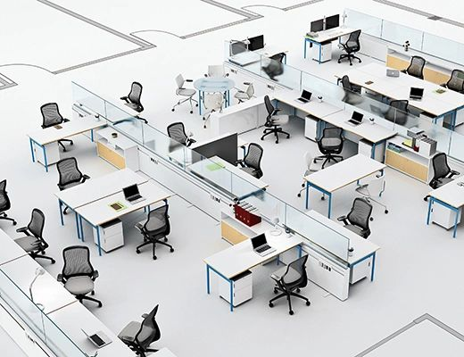

Dear Management: Prediction #3... of GOOD changes in our industry, that will come from this BAD virus.  
  
Business "needs" for office space are gonna change BIG time... and within those offices, actual spacing needs are gonna change too.  
  
Do loan officers really need offices?  Or can they just sit at a HUB station when they are in the office?  Can they just have meetings in a couple designated conference spaces, for the "new rare" instance they meet a client "in" the office?  
  
Does operations / accounting / secondary / marketing / HR / compliance / IT / etc... need offices? or even cubicles for that matter?  Can they work from HUB stations also?    
  
And, will some of these departments work mainly from home now?  Only coming into the office on a rotation of weekly "check in/gab session" days?  
  
Also... with ALL that above, do you (Mx. Mortgage Company) need all that retail and office space you pay such LARGE $'s for???  
  
LOTS will change...  
  
And if you don't think this is gonna change people's concept of how we work...  
  
You need open the door to your office... and look outside.