(Mr. Tenkey's Tips #280) www.mrtenkey.com

April 3, 2020

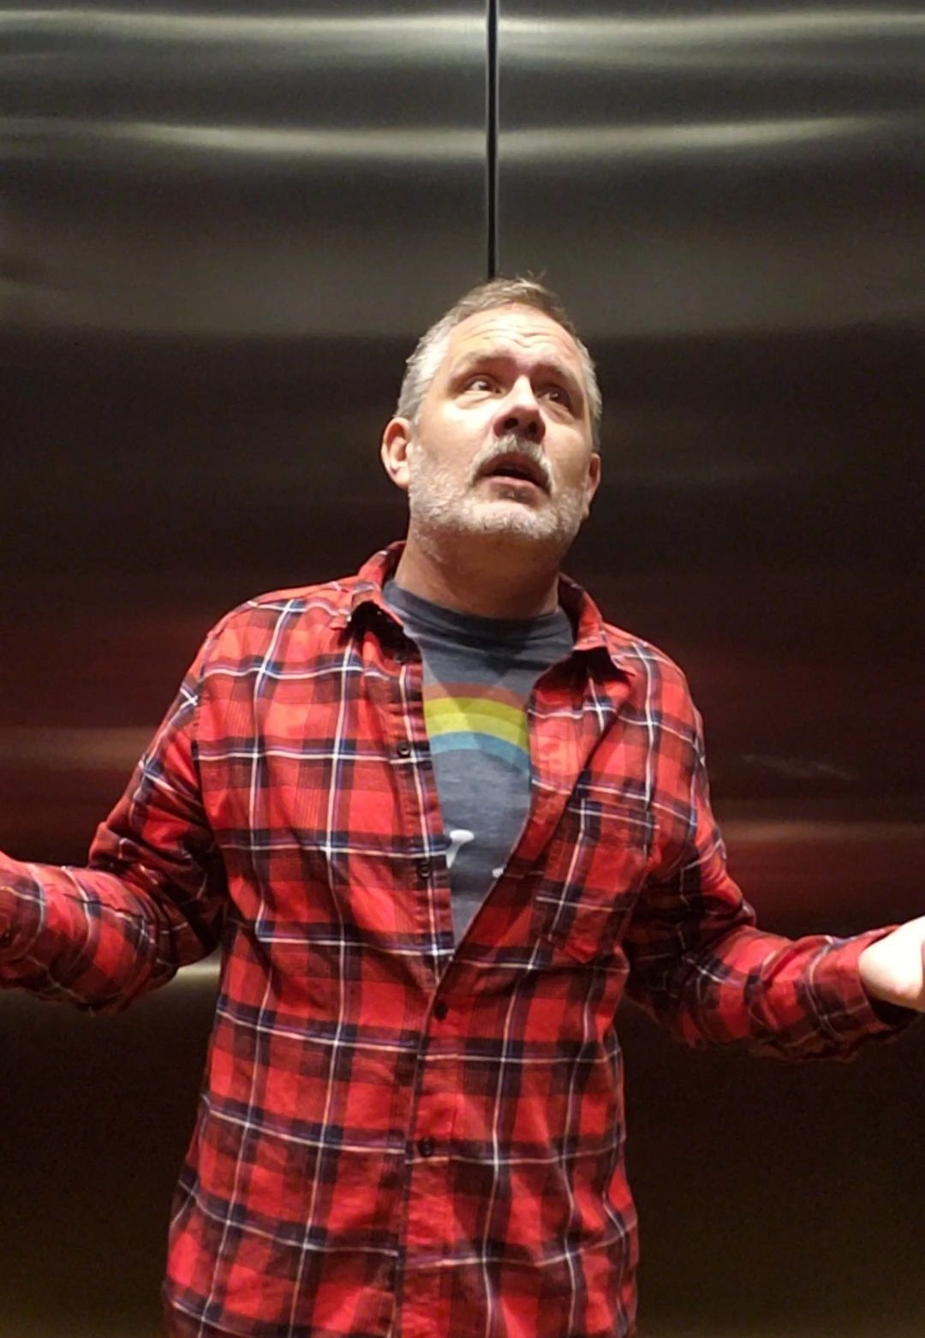

Disclosure:

\*\*\* I can't post videos here.  To see me in all my glory... go to my website ( the Accountant Gone Wild tab).\*\*\*

Dear Management: Prediction #4... of GOOD changes in our industry, that will come from this BAD virus.  
  
And one good thing... Accountants DO go wild some times!  
  
Currently, I'm one of like 3 holding down the fort at the office during this, and it's Friday... so why not.  
  
So my "Mr. Tenkey" tip for TODAY... is enjoy life no matter what the world brings to your plate.  
  
Cause.... I know I WILL survive!  And I hope you do to!