(Mr. Tenkey's Tips #281) www.mrtenkey.com

April 6, 2020

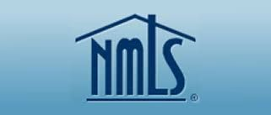

Dear Management: Prediction #5... of GOOD changes in our industry, that will come from this BAD virus.

FYI - NMLS= Nationwide Mortgage Licensing System and Registry

Ok, so my prediction is that an LO and their sponsoring company, will continue to be licensed in the respective states they originate.    
  
BUT the BIG change will be there will be no more "place from which they originate" requirement.  
  
No longer will they be tied to a specific location "branch" from which they have to originate.  
  
Think about it, we're already going through the test case now.  Most states have removed that "branch" requirement, due to COVID-19.  
  
But WHY did it take this virus to realize that an LO doesn't originate differently... at home, at their 2nd home in another state, on a park bench, on a zoom call, in a starbucks or tied down to a designated "branch".  
  
So my prediction is, that "branch" licensing will become history.  
  
The LO is licensed, the company is licensed... GO ORIGINATE! will be the slogan.  
  
Of course, management and oversight... along with all the compliance rules, etc. over client information privacy still stands and will need to be adhered to.  
  
But JUST THINK, if my prediction comes true...  
  
Just think of the streamlining in licensing that will occur.