(Mr. Tenkey's Tips #284) www.mrtenkey.com

April 9, 2020

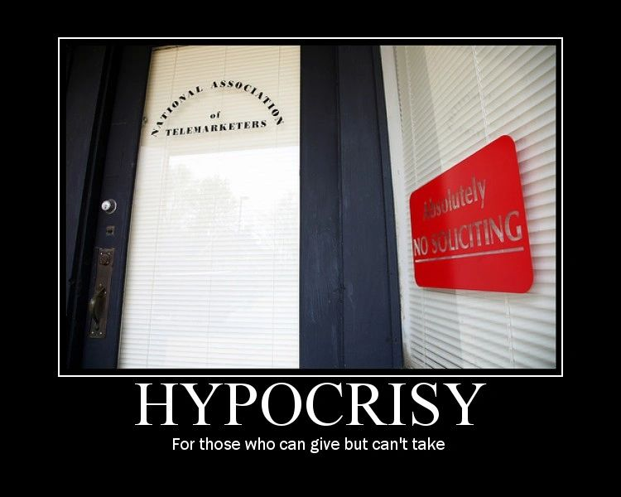

Dear Management:  One thing I see LOTS of... during these crazy times.  
  
Is even MORE crazy leadership communications... coming from a very "hypocritical" stature.  
  
This is BAD peeps, and even worse during times when the rank and file needs to be disciplined... in structure and mind.  
  
Because... your employees DO see through the smoke you're blowing...  
  
So the moral,  
  
LEAD BY A GOOD EXAMPLE and your employees will become good examples of your leadership.