(Mr. Tenkey's Tips #287) www.mrtenkey.com

April 14, 2020

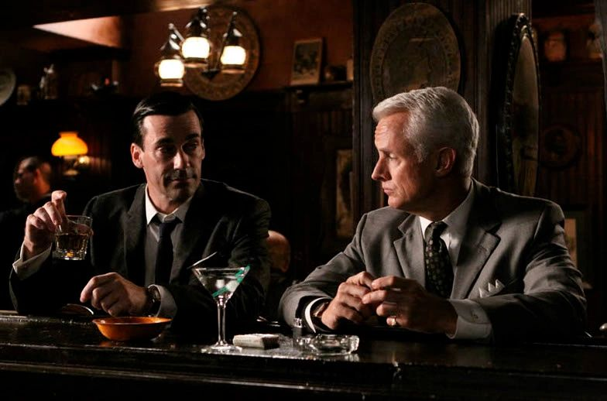

Dear Management:  Prediction #7... of GOOD changes in our industry, that will come from this BAD virus.  
  
Who would of thought that the good ol' days of 3 martini lunches, naps on the couch in your office, smoking allowed everywhere... would of gone by the weigh side?  
  
Well I don't remember those days, but I do remember a MUCH more ruckus mortgage industry...  
  
And at one time... "THAT is just the way it is!"  
  
Well, so were trips to far places for seminars and conferences, travel to tropical locals for conventions, overnight-trips to branch locations, quarterly company meetings, sales trips, etc....  
  
How's that going now?  with this virus crap...  
  
All those have been replaced by a personality (well some of us) and a camera.  
  
Companies can now see that online meetings/conferences DO work.  Leadership and employees are growing accustom to this as a new normal.  
  
Change is coming fast on this one... companies can already see the cost savings of reduced travel and entertaining costs... the longer this virus holds on.