(Mr. Tenkey's Tips #293) www.mrtenkey.com

April 22, 2020

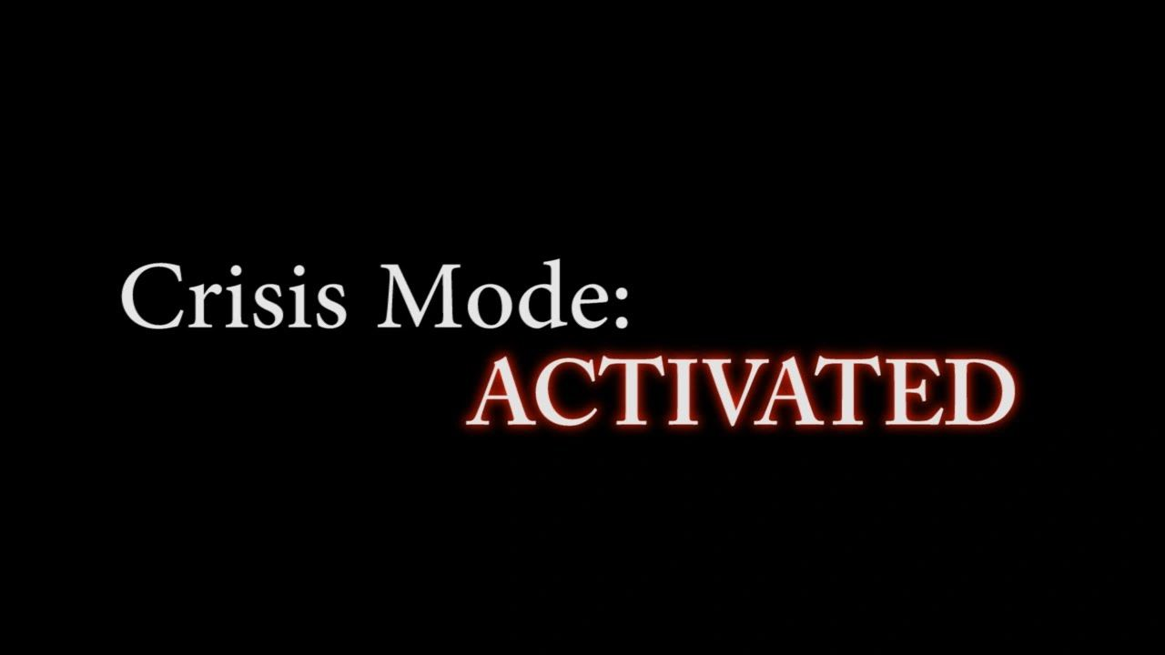

Dear Management:  Ok, we're well into the brunt of a CRISIS MODE situation these days...  
  
How ya doing?    
  
And YES... this is the BEST time to evaluate, not at the end of this, but now... in the heat of it all.  
  
Have you handled yourself well?    
Have you taken a deep breath, gathered the best info from the best sources?  
Have you actually made decisions or have you knee-jerked your way through things?    
What did you miss so far, that you shouldn't of?  
Are there things you could have done better from the start?  
  
How has your senior management team done?    
Have they made good decisions for the company?    
Have they been good leaders?  
  
How have your employees done?  
Have there been stand-outs that deserve advancement after this?  
Are there ones that should no longer be here?  
   
I can't ask all the questions, or answer any of these for you...  
  
But you should be doing BOTH right now.  
  
What better time to evaluate YOURSELF and YOUR PEEPS, than in the middle of the best evaluation time???... an ACTUAL crisis...