(Mr. Tenkey's Tips #296) www.mrtenkey.com

April 27, 2020

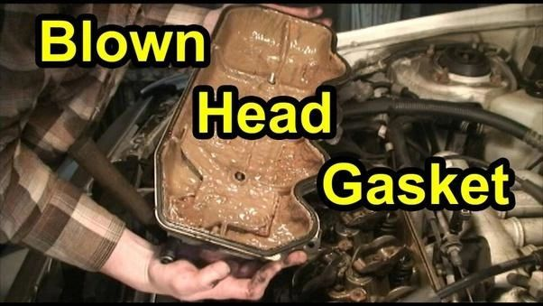

Dear Management: Message distortion... is water in the oil... pumping through your company's production engine.  
  
As a leader... your job is to be the oil to your company.  
  
Your messages (communication)... lubricate the wheels of that production engine.  
  
If the message is distorted... water enters the engine, causing corrosion.  
  
You won't see rust at first, but microscopic pitting is occurring... causing excessive wear.  
  
And the worst thing to production output... is excessive wearing down of your production staff's efficiency.  
  
So make your message MATTER!  
  
Gather ALL the information necessary to prepare your best message.  
Think through the effects of your message.  
Stay on course with your message.  
AND be consistent with your message.  
  
Now go, make those engines purr peeps!