(Mr. Tenkey's Tips #302) www.mrtenkey.com

May 5, 2020

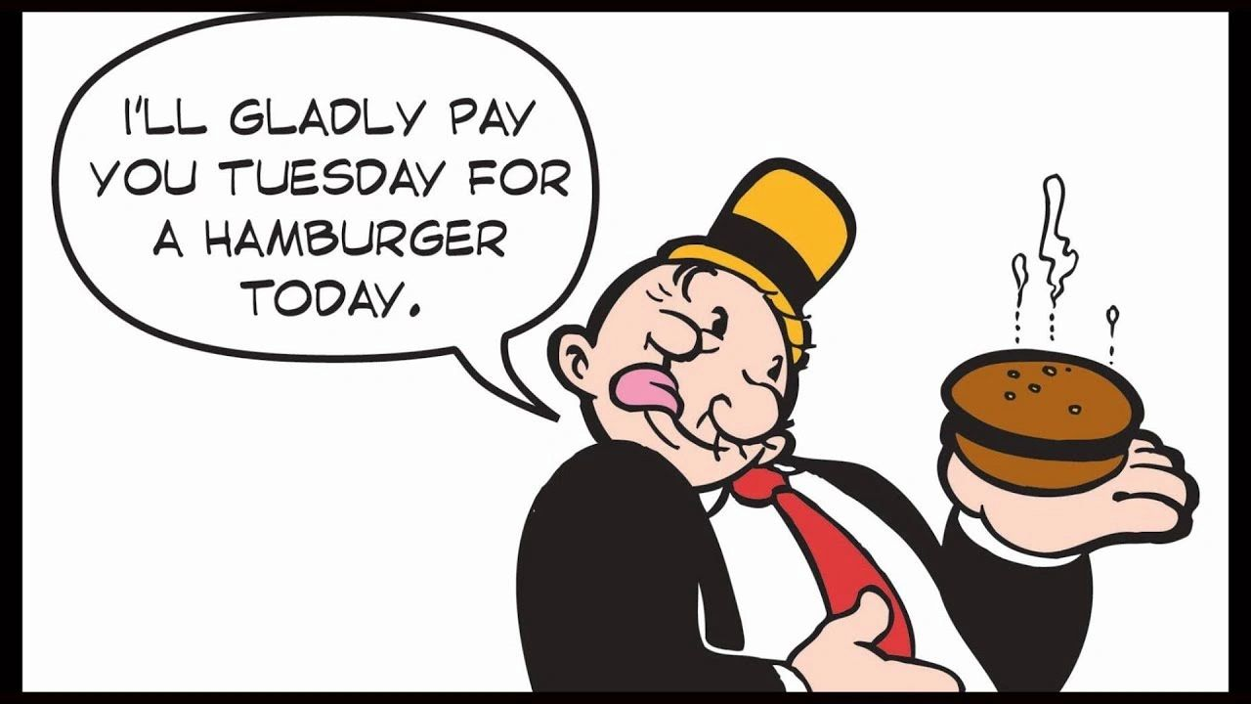

Dear Management: Many people interchange these payroll words/phases in normal conversation...  
  
Those phrases/words being: a draw, prepaid comp, a payroll advance, etc.  
  
No big deal normally, well until they do it in actual compensation situations and agreements.  
  
On it's face a simple slip of the tongue, but to the employee a possible HUGE mis-understanding!  
  
One path treats the amounts paid as a short-term loan (to be paid back from the ee's net payroll)... the other path treats it as prepaid payroll (hence taxes & w/h's are taken at the time of payment).  
  
So, when you tell the payroll department to give an employee a $5,000 advance and don't clarify...  
  
The employee either gets a $5,000.00 check that they have to repay from future net earnings, OR they get let's say $2,500.00, (where taxes, deductions and withholdings have already been taken out).  
  
So PLEASE CLARIFY yourself! It matters.  
  
And if you STILL don't think there's a difference... what would you rather be... fired? or laid-off?  
  
Either way, you're not working for the company right?  
  
SEE... I told you words (and their definitions)... matter.