(Mr. Tenkey's Tips #304) www.mrtenkey.com

May 7, 2020

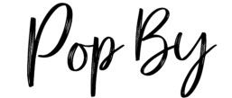

Dear Management: What will POP-BYs look like??? (Post-"stay at home order" addition)...  
  
Because life IS and WILL be different...  
  
SO, bring on Innovation! No more coffee mugs or candy...  
  
Bring on masks with funny mouths/smiles on them... for those that have to leave the house.  
  
Bring on personalized puzzles... for those who still can't go to school.  
  
Bring on stylized luggage tags... for those that want to get the hell out of Dodge.  
  
Bring on rubber gloves with polished nails painted on them... for those that still can't have their nails done.  
  
or just...  
  
Bring on a logo'd paper bags... for those that gave up during quarantine.  
  
But ABOVE all... BRING IT peeps!