(Mr. Tenkey's Tips #307) www.mrtenkey.com

May 12, 2020

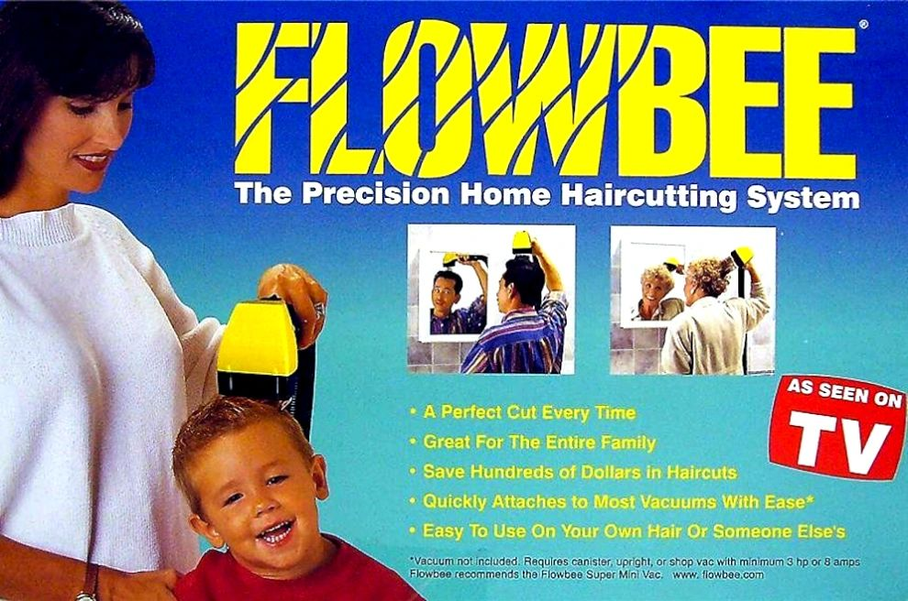

Dear Management: The typical TV ad is 30 secs or less!!!!  
  
And in that time... a concept is conveyed, a feeling is felt, an objective is obtained, a demand is dealt...  
  
YET.... some companies have meetings lasting 2 hours plus.  
  
Even worse... ending with no material outcome.  
  
If this is your company... I challenge you!!!  
  
To give each discussion point (let's be generous) 5 open minutes to be presented.  
  
That's 10 commercial breaks!!! to convey what someone wants to do... needs help with... needs a decision made on... etc.  
  
That transforms your meeting into a concept and decision pivot point... instead of a time sucking vacuum.  
  
And think about it, after 10 commercials... you know if you're gonna buy that Flowbee or not!  
  
MORAL  
  
Time management does not stop at the door of a conference room.